TP1 Design Proposal

Zhenhao Xiong

zxiong

Project Proposal:

* **Project Description:**

Battle Painters. It is a multiplayer competitive game. Players act as painters to draw on a piece of virtual paper. Player could draw on top of each other and when times up, the player who gets the most color wins the game. Player could get power-ups to strengthen its speed, thickness.

* **Competitive Analysis:**

Battle Painters. It is a local multiplayer game published by JJ Soft in 2000. My game is quite similar with this game. Players paint their color and cover other’s color to achieve the majority color on the paper. My game’s core gameplay is like this game, but I want to achieve more by adding some interesting power-ups and add a feature of dashing to move swiftly on paper.

Other fact is that I am going to create an online game using socket, which means I could play this game with my friends as long as the computer connects to the Internet.

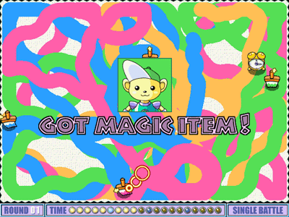

* **Structural Plan:**

Using OOP to manage the objects, including class of Painters, Power-Ups (Single power-up should inherit from the parent class).

Files:

Painter_server.py #Deal with connection and join in the room

Painter_client.py #Deal with client’s behavior and communication with the server

Painter.py #Class of painter

Powerup.py #Class of power-ups

* **Algorithmic Plan:**

Save an image of the painter frame by frame, and edit it with few pixels to change. (the new painter’s circle) In this way, I could get the data from an image 2d-pixel arraylist and calculate the majority at the end of game.

* **Timeline Plan:**

Apr-15: Finish the socket part of the game.

Apr-17: Finish the core gameplay of moving and drawing things on paper.

Apr-20: Implement power-ups

Apr-22: Implement UI and other images to replace the placeholder.

Apr-24: Almost finish the whole game, working on the design doc.

Apr-27: Fix bugs and polish the gameplay

Apr-30: Test with other people.

May-3: Finish the video and ready for delivery

* **Version Control Plan:**

Using Github to manage version control

<https://github.com/JoeXiongCMU/TP15112>

* **Module List:**

Socket: To develop a multiplayer game that uses socket to communicate.

Storyboard:

